Using Google Forms
by - Eric Curts

Table of Contents:
What is Google Forms?
Creating a new form
Adding collaborators to the form
Editing the form description
Editing form questions
Adding more questions and other items
Question types
1 - Text type
2 -Paragraph type
3 - Multiple Choice type
4 - Checkboxes type
5 - Choose From a List type
6 - Scale type
7 - Grid type
8 - Date type
9 - Time type
Inserting images
Inserting videos
Adding section and page breaks
Changing the theme of the form
Changing user settings for the form
Changing what happens after a form is submitted
Choosing where form data is saved
Sending the form out to users
Viewing responses to your form
Viewing a summary of responses as charts and graphs
Getting notified when a form is submitted

What is Google Forms?

Google Forms is a free tool from Google that allows you to do the following:
- Create forms, surveys, quizzes, and such
- Share the forms with others
- Allow others to complete the forms online
- Collect all the responses in a spreadsheet
- Provide you with helpful summaries of the collected data with charts and graphs
You access Google Forms through the Google Drive screen or the Google Forms web app.

You can use Google Forms with your personal Google account, or through a Google Apps for Education account. With a Google Apps for Education account you can also do the following:
- Require that respondents be from your Google Apps domain.
- Collect respondents usernames.

Creating a new form

Once you are in Google Drive you can create a new form as follows:  - Click the Create button in the top left corner  - Then click Form from the drop-down menu  - Your blank form will now be created and the Choose title and theme window will pop up.  - To name your form, type in the Title box where is currently reads Untitled form. You can always change this later.  - If you want to choose a theme for your form, scroll down through the available themes and click on the one you wish to use. You can change this later as well.  - Finally click OK when done.  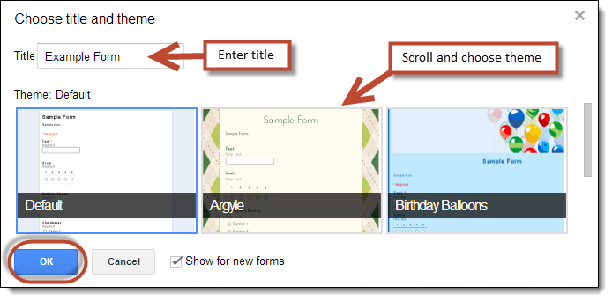 | 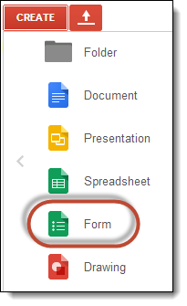

Adding collaborators to the form

Just like with other Google Documents, you can give other people edit rights to collaborate on the creation of your form. To add collaborators:
- From the edit mode of the form click File in the top menu bar.
- Then click Add collaborators...
- The normal Sharing settings window will open where you can share the form with other people.

Editing the form description

After creating your form, you can optionally add text for a description. Usually this is where you can explain to the user the purpose of the form, any special directions, or other helpful information.
- Below the title of the form, there is a box labeled Form Description.
- Simply click and type in that box to add your description.
- You can include web addresses in the description box and they will show as clickable links on the live form.
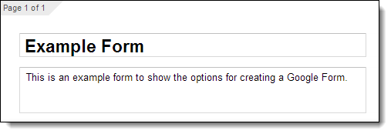

Editing form questions

When you create your form, your first question will be created as well. You can edit the question as follows:

- For Question Title you can type in the question you wish to ask.
- For Help Text you can add additional directions or clarification for the question.
- For Question Type you can choose between nine different types of questions (explained later).
- If the question type needs a list of answers (such as multiple choice or checkboxes) then you can fill in the available answers.
- To force the user to answer the question, check the Required question box.
- Click Done when finished.

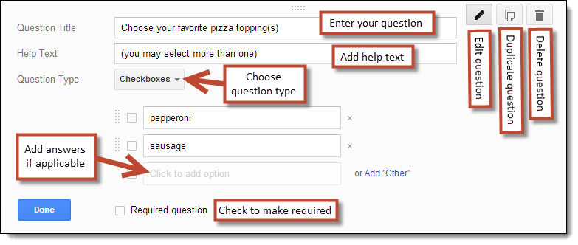

At any time you can also do the following to a question:
- You can edit a question by clicking the edit button (the pencil icon) in the top right corner.
- You can duplicate a question by clicking the duplicate button (the double-page icon) in the top right corner.
- You can delete a question by clicking the delete button (the trash can icon) in the top right corner.
- You can change the order of questions by clicking and dragging a question to a new location.

Adding more questions and other items

In addition to the one question you begin with, you can add more questions and other items to your form.

- To add an item you can click the Add item button below your last question, or click Insert in the top menu bar.  - The items you are able to add include:  - Basic question types: Text, Paragraph text, Multiple choice, Checkboxes, Choose from a list  - Advanced question types: Scale, Grid, Date, Time  - Layout items: Section header, Page break, Image | 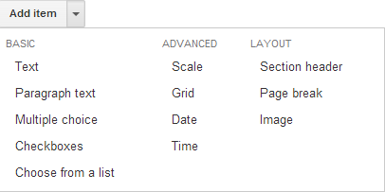

Question types

There are nine different types of questions you can include in a form:

1 - Text type
- For the Text type question, you simply type in a question and the user gets a one-line text box to enter their response. | 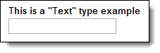

2 -Paragraph type
- For the Paragraph type question, you simply type in a question and the user gets a multi-line text box for their response.  - This type of question is well suited for open-ended or essay type responses. | 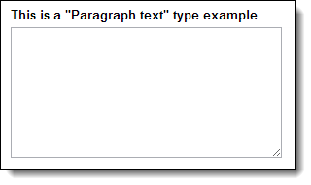

3 - Multiple Choice type
- For the Multiple Choice type question, type in your question.  - Then enter in as many options as you wish for the answer choices. You can also copy and paste in your list if you have it typed up elsewhere.  - You can also choose to add the Other option where the user will be allowed to add and choose a write-in choice for your list.  - When the user completes the question, they may only choose one of the choices you have provided | 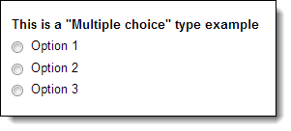

4 - Checkboxes type
- For the Checkbox type question, type in your question.  - Then enter in as many options as you wish for the answer choices. You can also copy and paste in your list if you have it typed up elsewhere.  - You can also choose to add the Other option where the user will be allowed to add and choose a write-in choice for your list.  - When the user completes the question, they can choose as many of the choices as they wish from what you have provided. | 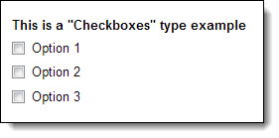

5 - Choose From a List type
- For the Choose From a List type question, type in your question.  - Then you can enter in as many options as you wish for the answer choices. You can also copy and paste in your list if you have it typed up elsewhere.  - Note: There is not an Other option like in the Multiple Choice and Checkbox types.  - When the user completes the question, they may only choose one of the choices you have provided from a drop-down list. | 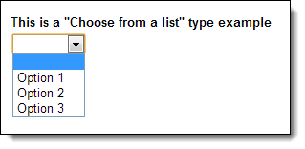

6 - Scale type
- For the Scale type question, type in your question  - Then you enter the starting point (0 or 1) and the ending point (up to 10) for your scale  - Optionally you can enter labels for the endpoints of your scale such as “Disagree the most” and “Agree the most”, or “Lowest ranking” and “Highest ranking”  - The user will be presented with a scale of values on which to place their response | 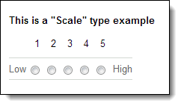

7 - Grid type
- For the Grid type question, begin by typing in your overall question or directions that will apply to each question in the grid.  - Then choose how many columns you want in the grid (1 to 5), and you provide descriptive labels for each column  - Then enter as many rows as you wish for the grid, and enter a question or statement for each.  - When the user completes the question, they will be presented with a grid of rows and columns and will need to click a single cell to place their response for each row. | 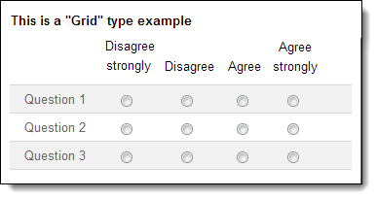

8 - Date type
- For the Date type question the user will simply choose a date from a drop down box or with up/down arrows.  - You have the option to include the Year or not.  - You have the option to include the Time or not. | 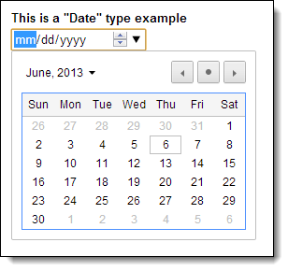

9 - Time type
- For the Time type question you can choose either the time of day format or duration format with hours, minutes, and seconds.  - The user will then select the time or duration using drop down menus and up/down arrows. | 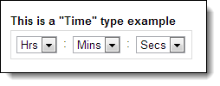

Inserting images

You can also insert pictures in your form, and can place them before or after a question or other part of your form. This is especially useful for quizzes to show the user maps, charts, and other images related to the questions in the form.

- To add a picture click the Add Item button or click Insert in the top menu bar.
- Then choose Image from the drop-down menu.
- The normal Google Docs Insert image window will open giving you many options for selecting the picture.

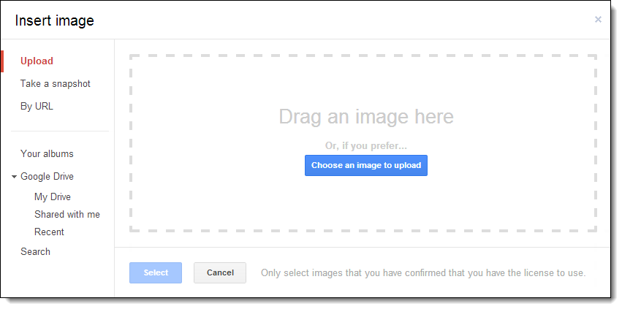

- Upload - You can browse your hard drive or network drive to locate and upload an image.
- Take a snapshot - If you have a webcam, you can take a picture and insert that.
- By Url - You can paste the web address of an image that is already online.
- Your albums - If you save pictures in Picasa Web Albums, you can browse through your albums and insert any image.
- Google Drive - Select images saved to your Google Drive or shared with you from others through Drive.
- Search - You can search for image from several online sources:
  - Google - A search of Google Images for public-domain pictures
  - Life - Pictures from Life Magazine
  - Stock Images - These are high quality clipart images

Note: Once you insert an image into the form you can click and drag it to place it elsewhere in the form, just like you can do with form questions.

Inserting videos

You can also insert YouTube videos in your form, and can place them before or after a question or other part of your form. This can be useful for quizzes where the user needs to watch a video and then respond to related questions.

- To add a video click the Add Item button or click Insert in the top menu bar.
- Then choose Video from the drop-down menu.
- This will open the Insert Video window where you can search for a YouTube video or paste in the video URL.
- Once you choose the video you want, click Select at the bottom to add it to your form.

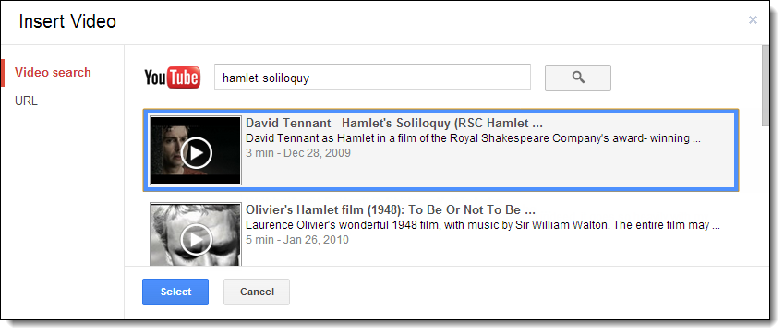
Note: Once you insert a video into the form you can click and drag it to place it elsewhere in the form, just like you can do with form questions.

Adding section and page breaks

If your form has a lot of questions you may want to break it up with section breaks or page breaks, and provide additional structure and information to the user.

To add a section break:
- First click the Add Item button or click Insert in the top menu bar.
- Then choose Section header from the drop-down menu.
- You can now enter in a section title in the Header text box.
- Optionally you can type in more information in the Description box.
- Click Done when finished.
- Now you can click and drag the section header to whatever location in the form you want.

To add a page break:
- First click the Add Item button or click Insert in the top menu bar.
- Then choose Page break from the drop-down menu.
- Optionally you can now enter in a page title in the Page title box.
- Optionally you can type in more information in the Description box
- Click Done when finished
- Now you can click and drag the page break to whatever location in the form you want.
- You can also determine where the user goes after a page break such as the next page, a specific page, or form submission.

Changing the theme of the form

Google Forms offers a large variety of themes to choose from to modify the color and style of your form. To change your form’s theme:

- First click on Theme... in the top menu bar.  - This will take you to a screen where you can scroll through available themes displayed as thumbnail images.  - Click on the theme you want and click OK.  - To view your form using the new theme, click View live form in the top menu bar. | 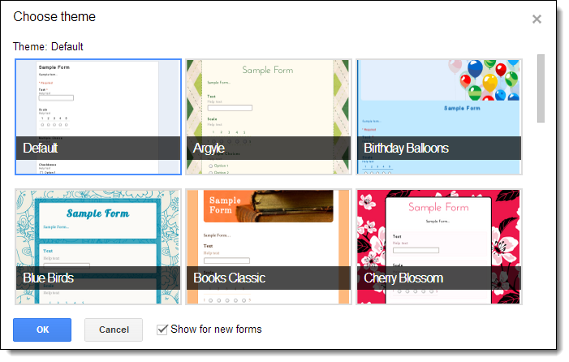
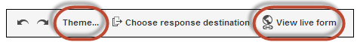

Changing user settings for the form

If you are using Google Forms through a Google Apps domain, there are several user settings that you can change for your Google Form. Each of these are controlled at the top of the form by selecting (or not) checkboxes.

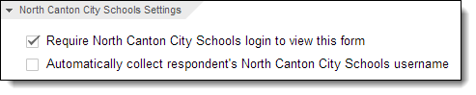
- Require [your domain] login to view this form - If you check this box then people will need to log in with a valid Google Apps account from your domain (such as your school) to access and complete the form.

- Automatically collect respondent’s [domain] username - This checkbox will determine if the form is anonymous or not. If you need to know which user goes with which responses (such as students completing the form as a quiz) then check this box.

Changing what happens after a form is submitted

At the bottom of the form is a section titled Confirmation Page where you can control what happens after a user submits the form. This includes the following:

- You can change the response message the user is given.  - You can give them a link to retake the form.  - You can give them a link to see all the results from other participants.  - You can give them a link to edit their responses. | 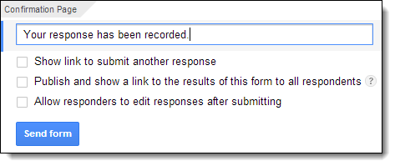

Choosing where form data is saved

Before you can have users actually fill out your form, you will need to do one last step, which is to choose where the user responses to the form will be stored. Most often you will want to save the data in a Google Spreadsheet for easy access and analysis.

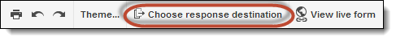

- Begin by clicking Choose Response Destination in the top menu bar.  - In the New spreadsheet box you can rename the spreadsheet if you want, although the default name is usually fine since it incorporates the name of the associated form.  - Click the Create button to generate and link the spreadsheet to the form. | 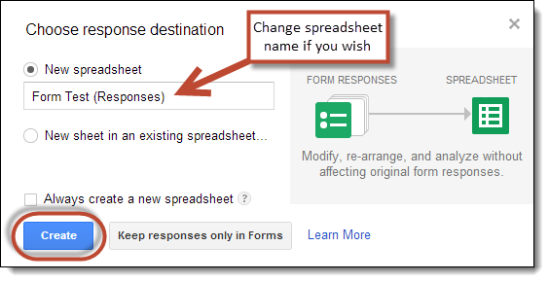

Sending the form out to users

When your form is ready, you can make it available to users in several ways.  - First, click the Send Form button in the top right corner of the edit screen. This will open the Send form window.  - If you want to email the form directly to users, click in the box labeled Send form via email. Here you can enter individual email addresses or email distribution groups. | 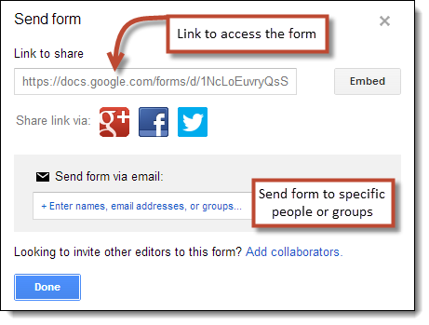

- Another option is to copy the form link from the Link to share box. You can then share that link with users in many ways:
  - Post the link on your website, blog, forum, or other online source.
  - Put the link inside another document and share that document (perhaps as a document with a whole list of links).
  - Turn the link into a QR Code
  - Use a URL shortener such as Tiny URL or Bitly

Viewing responses to your form

Once people begin filling out your form, their responses will be saved to the spreadsheet linked to the form. You can get to the spreadsheet in a couple of ways.

- From the edit screen on the form, simply click the View responses button.
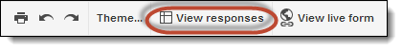
- Or from your Google Drive screen, simply locate and open the spreadsheet.

Once you have the spreadsheet open you will see all of the user responses, one user per row, with each column holding the data for each question in the form.

Just like with a regular spreadsheet you can perform many spreadsheet operations including sorting and filtering the data, creating charts, creating additional sheets, adding data and formulas to unused cells, and such.

Viewing a summary of responses as charts and graphs

Google Forms can show you a summary of the responses in graph and chart form. This can be helpful to identify trends or easily determine overall opinions.

To see this summary do the following:
- If you have the form spreadsheet open, click Form and then Show summary of responses.
- If you are in the edit mode of the form, click Responses and then Summary of responses.

In Summary view you will see:
- Bar graphs showing the frequency of responses to Checkbox, Scale, and Grid questions
- Circle graphs showing percentages of responses to Multiple Choice questions
- Total numbers and percentages for each possible response
- The first several responses for any of the Text or Paragraph questions
- A line graph showing the amount of responses per day since you shared the form

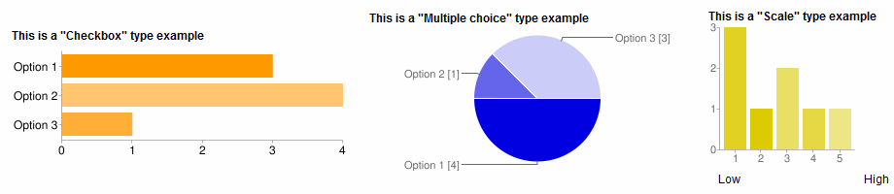

Getting notified when a form is submitted

If you have a form that will be getting responses over a long period of time, you will want to be notified when someone new submits their responses. You can configure the form spreadsheet to send an email to you in such situations.

- First open the Spreadsheet for the form.  - Click Tools in the top menu bar  - Choose Notification rules... from the drop-down menu  - This will open a window where you can make the settings  - You should check the notify box for A user submits a form  - You should check the notify box for Email - right away  - Then click Save  - You will now get sent and email anytime someone completes your form (along with a convenient link to the form spreadsheet of responses) | 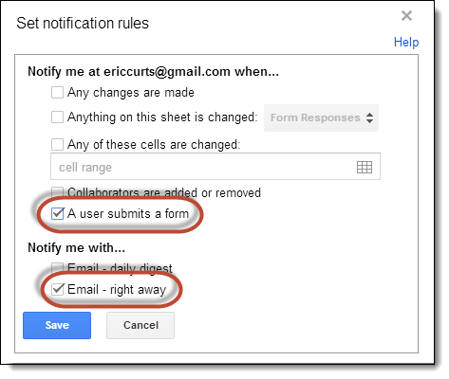

For more resources see:
- “Google Forms for Everything!” training video:
http://www.youtube.com/watch?v=HXA5_LjkMoQ
- “Google Forms for Everything!” site:
http://www.appsusergroup.org/presentations/google-forms-for-everything

Copyright 2010-2013 - Eric Curts - ericcurts@gmail.com - www.ericcurts.com
This document is licensed under a Creative Commons Attribution Non-Commercial 3.0 United States license. For more information about this license see http://creativecommons.org/licenses/by-nc/3.0/ (In short, you can copy, distribute, and adapt this work as long as you give proper attribution and do not charge for it.)

